

[v_Head_of_Households_Name] [v_Case_Mailing_Address_Full_3_Lines]
Date of Notice: [v_Date_current_date] CBMS Case#: [v_Case_Number]

Supplemental Nutrition Assistance Program (SNAP) Request for More Information

We Need Additional Information From You

Dear [v_Head_of_Households_Name],

Usted notificó un cambio de domicilio el [v_SNAP_CRF_date]. Dado que se ha mudado, necesitamos más información sobre sus gastos de vivienda y servicios públicos. Necesitamos esta información para poder determinar si es necesario realizar algún cambio en sus prestaciones del SNAP. Es posible que tenga derecho a recibir más prestaciones si sus gastos de vivienda han aumentado con respecto a la cantidad que tenemos presupuestada actualmente en su expediente. En esta carta se detalla qué información necesitamos y qué pasos debe seguir para hacérnosla llegar.

¿Qué tiene que hacer?

Por favor, confirme o actualice los gastos que figuran en las páginas siguientes antes del [v_SNAP_Due_date].

¿Cómo puede proporcionarnos la información que necesitamos?
Elija la opción que le resulte más fácil.

En línea:
Cargue este documento completado en CO.gov/PEAK o mediante la aplicación móvil MyCOBenefits en su smartphone. Si no tiene una cuenta, puede crear una.

En persona o por correo:
Entregue este documento completado en la recepción de su oficina local o en el buzón. También puede enviarlo por correo a
[v_SNAP_County_Name] Servicios Sociales del Condado [v_SNAP_County_Address_Full_3_Lines]

*Envíe copias, no documentos originales. No podemos devolverle ningún documento original a usted.
- Por fax: [v_SNAP_County_Fax]

Si necesita ayuda para rellenar este documento, póngase en contacto con el asistente social de su condado.

¿Qué pasará con sus prestaciones?
Si no nos facilita la información que necesitamos antes del [v_SNAP_Due_date] es posible que se produzca un cambio en sus prestaciones del SNAP. Si esto ocurre, recibirá una carta por separado en la que se le indicará el importe modificado y los pasos que debe seguir para presentar una apelación.

What if you need more help?

If you have questions, need to update your information, or need help understanding this notice, please contact us:

 | Phone: [v_Primary_Worker_Correspondence_Phone]  Toll-Free: [County Toll-Free Number or 1-800-816-4451]
 | PEAK: http://CO.gov/PEAK  - Sign up to go paperless, get email or text notifications  - See what benefits you have and when they need to be renewed  - Report changes  - Apply for other benefits
 | Mailing Address:  [v_Worker_Office_Mailing_Address_Line_1] [v_Worker_Office_Mailing_Address_Line_2] [v_Worker_Office_Mailing_Address_Line_3]
 | In-person Services:  [v_Worker_Office_Physical_Address_Line_1] [v_Worker_Office_Physical_Address_Line_2] [v_Worker_Office_Physical_Address_Line_3]
 | Fax:  [County Fax Number]

For notices in large print or another format, please call our helpline at [v_Primary_Worker_Correspondence_Phone] TDD (telecommunication device for the deaf).
Si lo solicita, podemos traducir esta información para usted. Por favor, llame [v_Primary_Worker_Correspondence_Phone].

Help in your Language

Cash Assistance: [v_Bable_contact_CA]
Supplemental Nutrition Assistance Program (SNAP): [v_Bable_contact_FA]
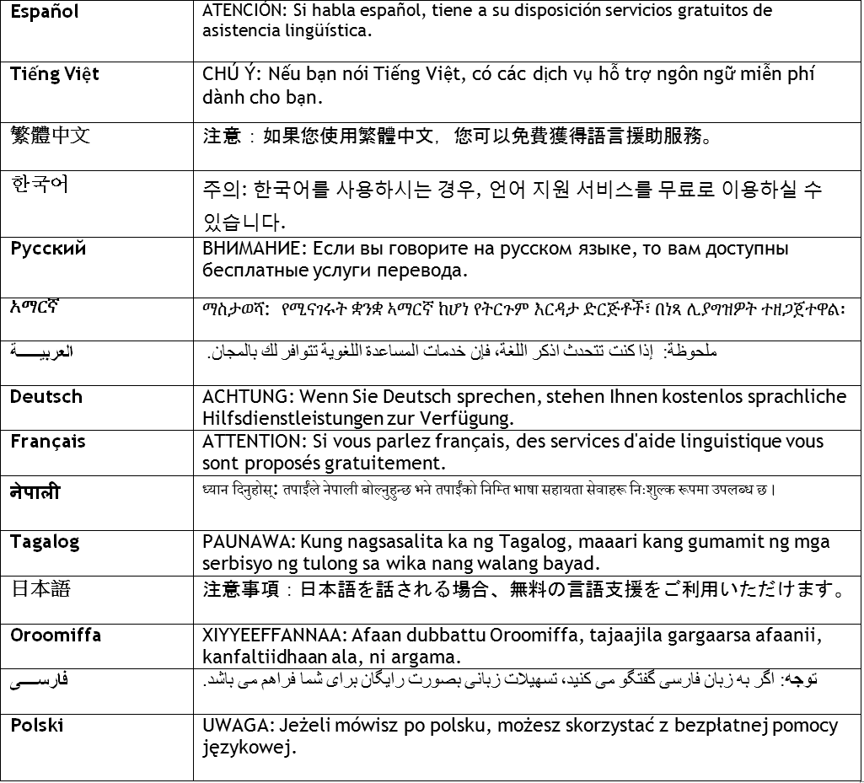



SNAP Request for More Information, Address Change

Sent to:
[v_Case_Name] [v_Case_Mailing_Address_Full_3_Lines]
Case #: [v_Case_Number]

To complete this form, please:
!
Return this form to:
[v_Primary_Worker_Correspondence_Name] [v_Worker_Office_Physical_Addr_Full_3_Lines] [v_Primary_Worker_Correspondence_Phone]
Return form by:
[v_SNAP_Due_Date]
- Use block letters and write using BLUE or BLACK ink
- Review all pre-filled information (grey fields) for accuracy
- Any rows filled with “XXXXX” do not require your review.
- If you need additional space than what is provided, please send this form
back with additional pages
- If you need assistance completing this form, contact the county office


1 By signing below:
- I understand that any changes reported can result in an increase, reduction, or termination of benefits.
- Turning this form in incomplete and/or after the due date can result in a delay of benefits being issued.
- I have read this form to continue my benefits and to the best of my knowledge and belief, my answers are true. This information
includes the shelter and utility expenses I am currently responsible for at my new address.
- I understand and agree to the information provided in the section titled “What I Should Know.”
- I have the right to apply again for SNAP benefits by submitting an application for assistance as long as it has my name, address, and signature. I can send this application in by mail, drop it off at the county office, or through an authorized representative. If everyone in my household receives SSI, I can apply again for benefits at the local Social Security office.

SIGN HERE DATE SIGNED (MM/DD/YYYY):

/ /

2
Please report if you have any changes in what you pay for rent/mortgage, home insurance, property taxes, HOA fees, and utilities, AND if you have any new things that you pay for:
2A
Update currently on-file information about expenses in your household:

Person Responsible for Expense | Type of Expense | Amount | How Often Billed | Change |  | How much was the last bill? (If you are no longer responsible for this, please write 0) | How Often is this person billed?
[v_indvName] | [v_expType] | [v_expAmou nt] | [v_frequenc y] | YES | NO | $
XXXXXXXXXXXX | XXXXXXXXXXXXX | XXXXXX | XXXXXXX | YES | NO | $
XXXXXXXXXXXX | XXXXXXXXXXXXX | XXXXXX | XXXXXXX | YES | NO | $
XXXXXXXXXXXX | XXXXXXXXXXXXX | XXXXXX | XXXXXXX | YES | NO | $
XXXXXXXXXXXX | XXXXXXXXXXXXX | XXXXXX | XXXXXXX | YES | NO | $
XXXXXXXXXXXX | XXXXXXXXXXXXX | XXXXXX | XXXXXXX | YES | NO | $
XXXXXXXXXXXX | XXXXXXXXXXXXX | XXXXXX | XXXXXXX | YES | NO | $
XXXXXXXXXXXX | XXXXXXXXXXXXX | XXXXXX | XXXXXXX | YES | NO | $

2B If your household has any new expenses, please report below. Even if you are behind on paying bills, let us know how much you are responsible to pay when answering questions about your expenses:
Expense Type: Rent/Mortgage Heating/Cooling
Electricity Only
Water Trash
Phone Other:
Weekly
Every 2 Weeks
Monthly
Other:
#1
Person Responsible for Expense:
When did this person become responsible

for this expense? (MM/DD/YYYY) / /
Amount: How often?
$

#2
Expense Type: Rent/Mortgage Heating/Cooling
Electricity Only
Water Trash
Phone Other:
Weekly
Every 2 Weeks
Monthly
Other:
$
Person Responsible for Expense:

When did this person become responsible

for this expense? (MM/DD/YYYY) / /
Amount:

How often?

#3
Expense Type: Rent/Mortgage Heating/Cooling
Electricity Only
Water Trash
Phone Other:
Weekly
Every 2 Weeks
Monthly
Other:
$
Person Responsible for Expense:

When did this person become responsible

for this expense? (MM/DD/YYYY) / /
Amount:

How often?

Have you received LEAP (energy assistance) at this address in the past 12 months?
Do you receive housing assistance at your new address (i.e. Section 8, housing vouchers, etc)?
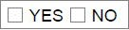
If yes:
Who is providing the assistance? How frequently is the assistance being provided? How much assistance is being provided?

