I want the normal WP editor on this wordpress site

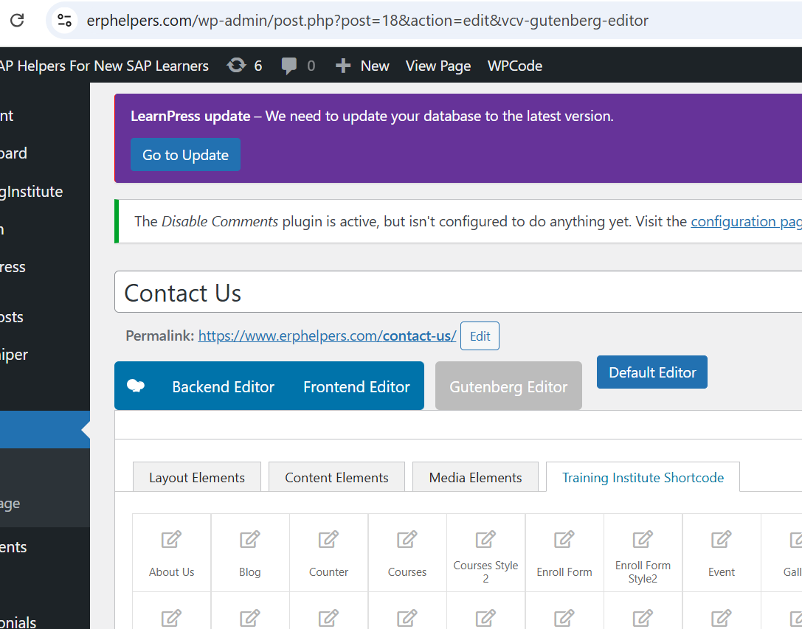

This url is not showing the contact page. Need to fix this
https://www.erpraj.com/contact.php

Message sent here could not be received by the recipient :-
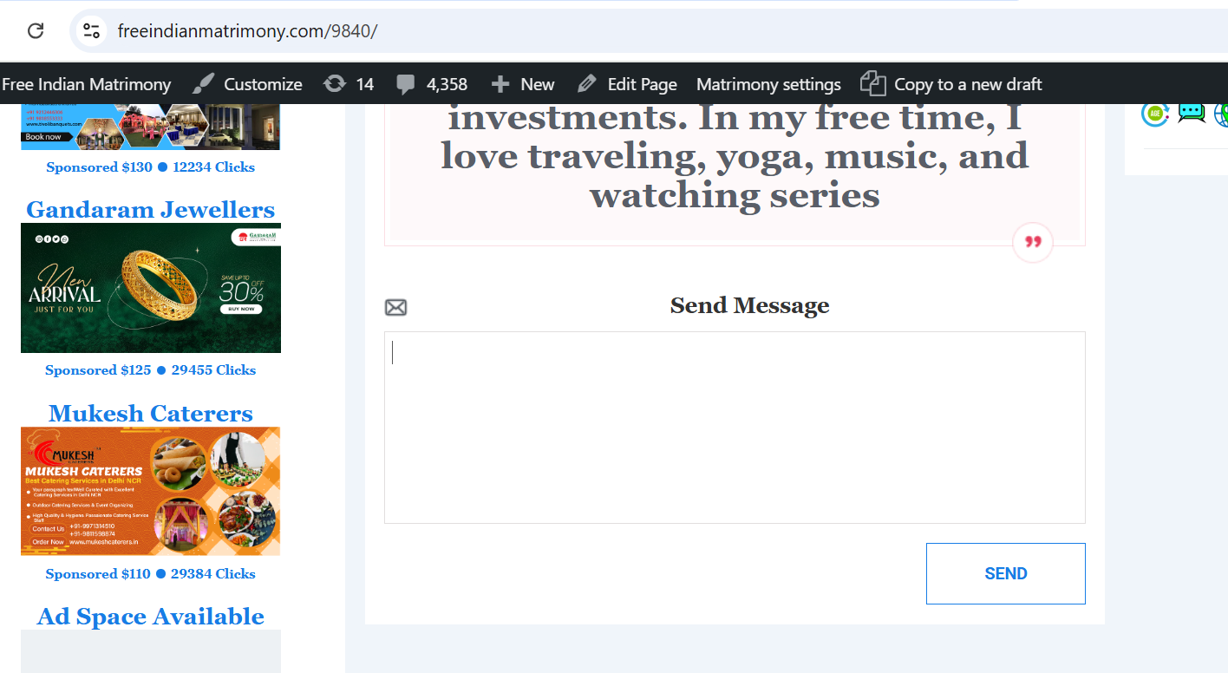

The contact us message sent here is not being received, need to check this
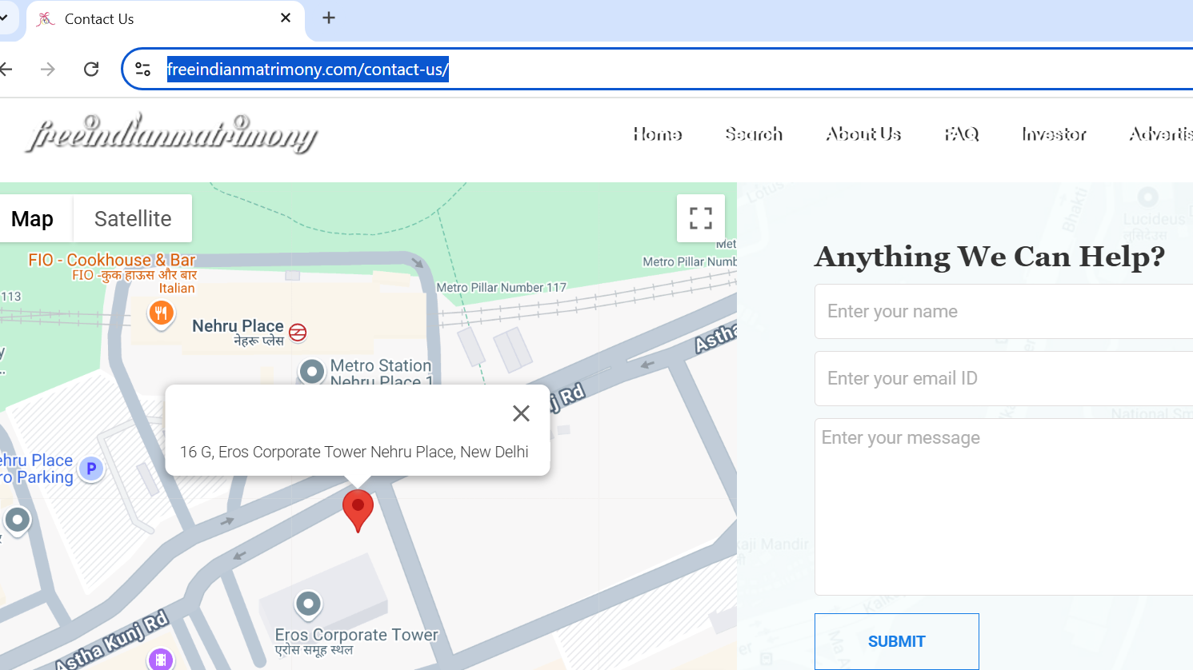

Here is the message from server admin regarding this

