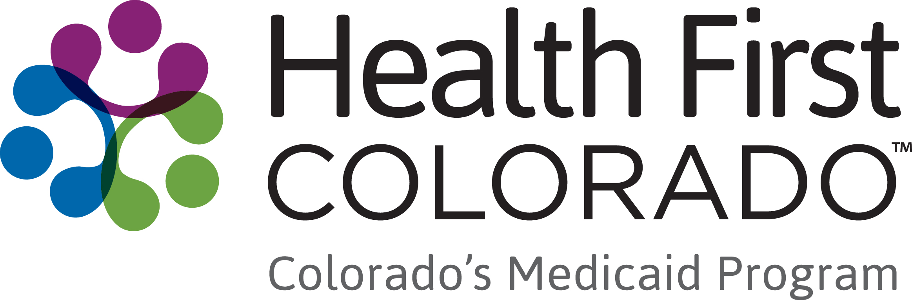
Dear HCBS Waiver Member,
You are receiving this letter because you may have new options available to you at your annual planning meeting about your Home and Community-Based Services. This meeting is called your Continued Stay Review.
Colorado is starting a new program called Community First Choice (CFC) on July 1, 2025. This program covers the services listed below, and all current HCBS waiver members can access these services starting at their annual planning meeting for their plan years starting on or after July 1, 2025. If you are already receiving any of these services, you will continue to get these services and may be able to get additional services or have new options for how those services are delivered/provided.
Your case manager will go through the same assessment process they do every year to assess your service needs. If you have an assessed need for any CFC services listed below, you may access that service through CFC and continue to receive all your other needed waiver services through your HCBS waiver.
It is important for HCBS waiver members to receive at least one waiver service per month to remain eligible for their HCBS waiver and for CFC.
To see definitions for the services below, visit hcpf.colorado.gov/long-term-services-supports-benefits-services-glossary.
Personal Care
- Including the choice of using Consumer Directed Attendant Support Services (CDASS), In-Home Support Services (IHSS) or traditional agency service delivery models
- NEW: Acquisition, Maintenance, and Enhancement of Skills (AME) task
Homemaker
- Including the choice of using CDASS, IHSS or traditional agency service delivery models
- NEW: Acquisition, Maintenance, and Enhancement of Skills (AME) task
Health Maintenance Activities
- Including the choice of using CDASS or IHSS service delivery models
Personal Emergency Response Systems (PERS)
Medication Reminders
Transition Setup
Home Delivered Meals
Remote Supports and Remote Supports Technology
One of the biggest changes with CFC is that anyone using Personal Care, Homemaker, or skilled care services will now be able to self-direct their care by controlling their own budget, hiring and firing their attendants, and training the people who provide their care for these services. To learn more about self-direction through Consumer Directed Attendant Support Services (CDASS) or In-Home Support Services (IHSS), please visit Consumer Direct Care Network’s website (consumerdirectco.com/).
If your current HCBS services will all be covered through the CFC program in the future, you will be able to use the new Wellness Education Benefit through your HCBS waiver to continue to receive at least one waiver service per month (hcpf.colorado.gov/wellness-education-benefit).
If you have questions about this change, please contact your Case Manager or visit the CFC webpage for more information (hcpf.colorado.gov/community-first-choice-option).
Thank you,
Health First Colorado (Colorado Medicaid)

If you experience any issues while Colorado transitions to the CFC program
We recognize that changes to the way we provide our programs can cause disruption. While CFC is intended to expand your access to services and create additional benefit and value for members, there may be unintended impacts to members. We have worked hard to lessen the impact, but if you experience any issues with setting up your services, please first contact your Case Management Agency. If they are unable to answer your questions or resolve your issue, please visit https://www.healthfirstcolorado.com/countyfeedback/ and submit a complaint webform.

If you think you have been treated unfairly
The Colorado Department of Health Care Policy and Financing (HCPF) oversees Health First Colorado (Colorado Medicaid) and Child Health Plan Plus (CHP+).
The Colorado Department of Health Care Policy & Financing does not discriminate on the basis of race, color, ethnic or national origin, ancestry, age, sex, gender, gender identity and expression, sexual orientation, marital status, religion, creed, political beliefs or disability in any of its programs, services, and activities.
To file a discrimination complaint or request free disability or language aids and services, contact the Colorado Department of Health Care Policy & Financing, 504/ADA Coordinator:
US Mail: 303 E. 17th Avenue, Suite 1100, Denver, CO 80203
Phone: 303-866-6010 or state relay 711
Fax: 303-866-2828
Email: hcpf504ada@state.co.us
You can also file a civil rights complaint with the U.S. Department of Health and Human Services Office for Civil Rights:
- Complaint Portal: ocrportal.hhs.gov/ocr/cp/complaint_frontpage.jsf
- Complaint Forms: hhs.gov/civil-rights/filing-a-complaint/index.html
- US Mail: 1961 Stout Street, Room 08-148, Denver, CO 80294
- Phone: 800-368-1019, TDD: 800-537-7697
- Fax: 202-619-3818

