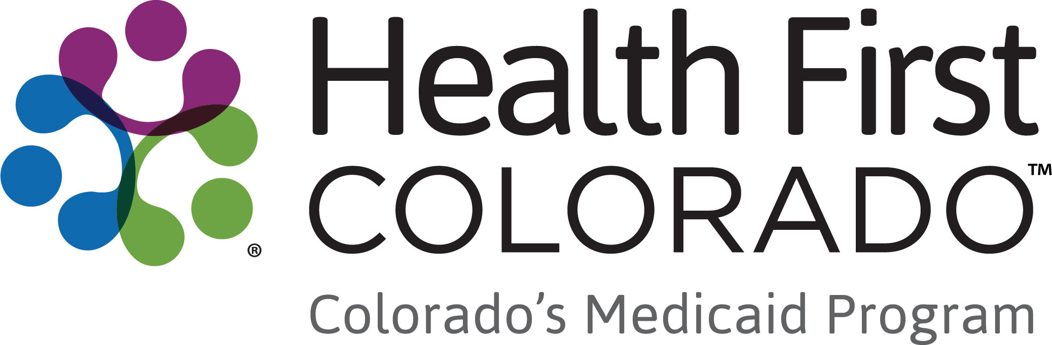
303 E. 17th Ave. Suite 1100
Denver, CO 80203
May 2025
[Name of Child]
c/o [Parent(s) Name]
[Address Line 1]
Another Line
555 Address St. Apt. 55
Denver, CO 80555

Your Child’s Waiver is Changing
Dear [Parent(s)Name]:
Your child is currently receiving benefits through the Health First Colorado (Colorado’s Medicaid program) Children’s Home and Community Based Services (CHCBS) waiver. We are writing to let you know that waiver is merging with another waiver for children. The new waiver will be called the Children with Complex Health Needs (CwCHN) waiver. Your child will be transferring to the new CwCHN waiver. We are doing this to streamline our programs and expand benefits to children.
Your child will not lose any of their current Health First Colorado benefits and coverage because of this change. Your child will continue to have access to In-Home Services and Supports (IHSS) Health Maintenance Activities (HMA) through a new program called Community First Choice (CFC). You will continue to have the option to be a parent caregiver for your child. Eligibility requirements for IHSS Health Maintenance Activities are not changing.
Your child will transfer over to the new CwCHN waiver when they have their annual reassessment between July 1, 2025, and June 30, 2026. For more information about these changes, please see the fact sheets included with this letter or contact your case manager.
Your child’s case manager will contact you before your child’s annual reassessment to help you. If you have questions before then, please contact your case manager:

Case Manager: [Case Manager Name]
Phone: [CM Phone]
Email: [CM email]

Included with this letter are two fact sheets explaining the CwCHN waiver and CFC. You can also visit hcpf.colorado.gov/community-first-choice-option to learn more about both the CwCHN waiver and CFC.

Sincerely,
Lana Eggers
Waiver Innovation and Compliance Section Manager
Office of Community Living
Enclosure(s)
cc: Insert name, Insert title

