
303 E. 17th Ave. Suite 1100
Denver, CO 80203

NEW Children with Complex Health Needs (CwCHN) Waiver Fact Sheet
February 2025

What is the Children with Complex Health Needs (CwCHN) waiver?
The Children’s Home and Community-Based Services (CHCBS) waiver is being merged with the Children’s Life-Limiting Illness (CLLI) waiver, and the merged waiver will be retitled as the Children with Complex Health Needs (CwCHN) waiver. The CwCHN waiver will be available to members who are currently eligible for or enrolled in either the CLLI or CHCBS waiver. The services available in the merged CwCHN waiver will include all services in the CLLI waiver with the addition of the Wellness Education Benefit (WEB), and members will also have access to all services under Community First Choice (CFC) starting July 1, 2025.

What services will be available through the CwCHN waiver?
The implementation of CFC moves the In-Home Support Services (IHSS) Health Maintenance Activities (HMA) service from the CHCBS waiver into CFC. This change leaves only the Wellness Education Benefit on the CHCBS waiver. The Department of Health Care Policy & Financing (HCPF) is using this as an opportunity to expand benefits to children by merging the CHCBS waiver with the CLLI waiver, making all services in CLLI available to those members currently using CHCBS waiver services.

Members currently enrolled in the CHCBS waiver will continue to have access to IHSS Health Maintenance Activities, including parent caregiver, the same as they do now, it will just be offered through CFC instead. There are no additional eligibility requirements for accessing IHSS under CFC.

CwCHN waiver services will include:
- Counseling/Bereavement Services
- Expressive Therapy
- Massage Therapy
- Palliative/Supportive Care
- Respite
- Therapeutic Life-Limiting Illness Support
- Wellness Education Benefit (WEB)

Members enrolled in the CwCHCN waiver will also have access to all Community First Choice (CFC) services if they have an assessed need, as well as all necessary services on Health First Colorado. Age-appropriate guidelines will still apply when assessing children for CFC services, which are listed below:

- Personal Care
  - Including the choice of using Consumer Directed Attendant Support Services (CDASS) or In-Home Support Services (IHSS), or traditional agency service delivery models
  - NEW: Acquisition, Maintenance, and Enhancement of Skills (AME) task
- Homemaker
  - Including the choice of using CDASS, IHSS, or traditional agency service delivery models
  - NEW: Acquisition, Maintenance, and Enhancement of Skills (AME) task
- Health Maintenance Activities
  - Skilled care option through CDASS or IHSS service delivery model
- Personal Emergency Response Systems (PERS)
- Medication Reminders
- Transition Setup
- Home Delivered Meals
- Remote Supports and Remote Supports Technology

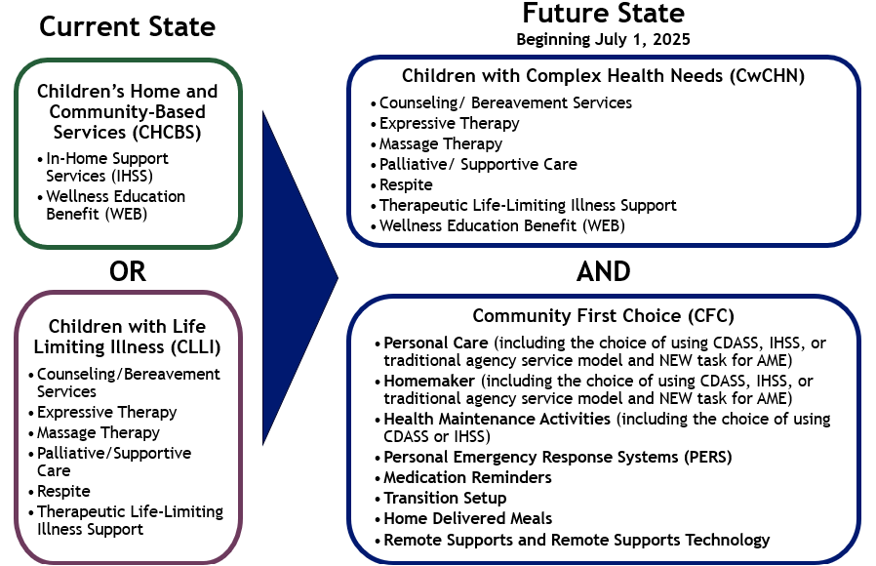

Who is eligible for the CwCHN waiver?
The CwCHN waiver will have expanded eligibility criteria to capture the current CHCBS and CLLI populations. To be eligible for the CwCHN waiver, you must meet the following criteria:

- Under 19 years of age
- Meet level of care (LOC) for a nursing facility or hospital
  - Meeting level of care means that an individual has a risk of going into a nursing facility or hospital if they cannot receive services in the home or community
- Meet the Federal Social Security Administration (SSA) disability definition and/or is a Supplemental Security Income (SSI) recipient
- The child’s income must be less than three times the current maximum Social Security Income (SSI) limit and their countable resources must be less than $2,000
  - Only income and resources for the member are considered. Parent income and resources are not considered for the child's eligibility.

What can I expect when the new waiver is implemented?

Current CHCBS Members
For current CHCBS members with renewal dates between July 1, 2025 to June 30, 2026, your case manager will help you transition to CFC and the CwCHN waiver at the time of your Continued Stay Review (CSR). Your case manager will be responsible for enrolling you into CFC and the CwCHN waiver, explaining the new options that may be available to you, and going through the service planning process. At that time, you will be able to access CwCHN services and CFC services. You will be able to continue receiving Health Maintenance Activities through IHSS, it will just be under CFC instead. If your parent provides that care, that option will still be available under CFC.

Current CLLI members
You will be automatically transitioned to the CwCHN waiver starting July 1, 2025. Your services and providers will all remain the same, with the addition of the Wellness Education Benefit (WEB). You will have access to CFC services at the time of your Continued Stay Review and your case manager will be responsible for enrolling you into CFC, explaining the new options that may be available to you, and going through the service planning process.

New Members
You will need to reach out to your local Case Management Agency after July 1, 2025 to begin the eligibility and assessment process. Visit hcpf.colorado.gov/case-management-agency-directory to find contact information for the agency in your area. You will be assessed for CFC and waiver services at the same time. You will have access to the CwCHN and CFC services that help you live in the community. If you would have historically qualified for CLLI or CHCBS waivers, you will now qualify for CwCHN and CFC.

How can I learn more about CFC and CwCHN waiver?
Visit hcpf.colorado.gov/community-first-choice-resources for more information on CFC, the CwCHN waiver, and the WEB.

Additionally, if you have any questions regarding these upcoming changes, email the CFC inbox at hcpf_cfc@state.co.us.

