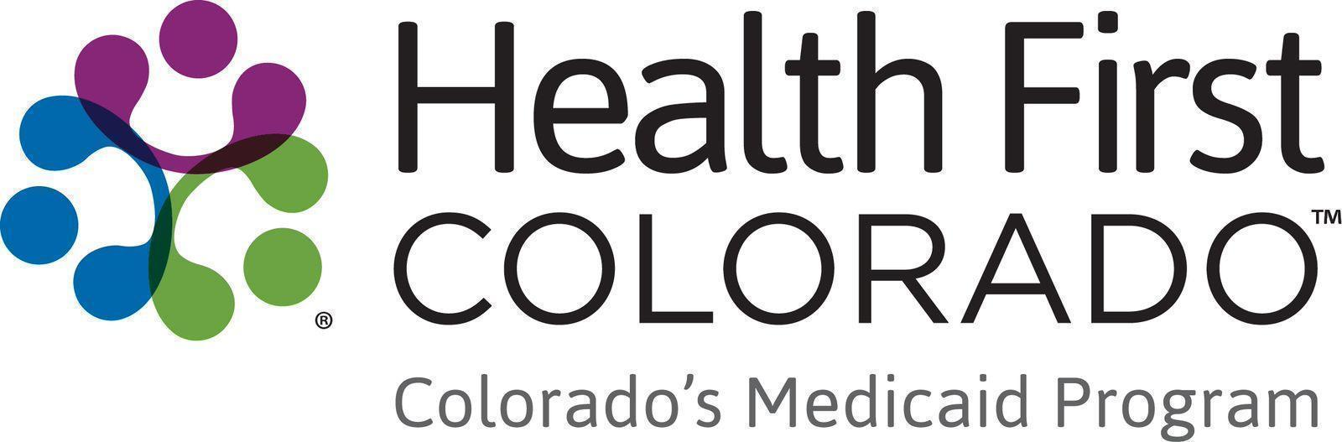

Member Videos Toolkit
Thank you for helping share the impact that Health First Colorado has on Coloradans across the state.

If you have any questions about the materials in this toolkit, please email Thessica Covato at thessica.covato@state.co.us

Tom’s Story

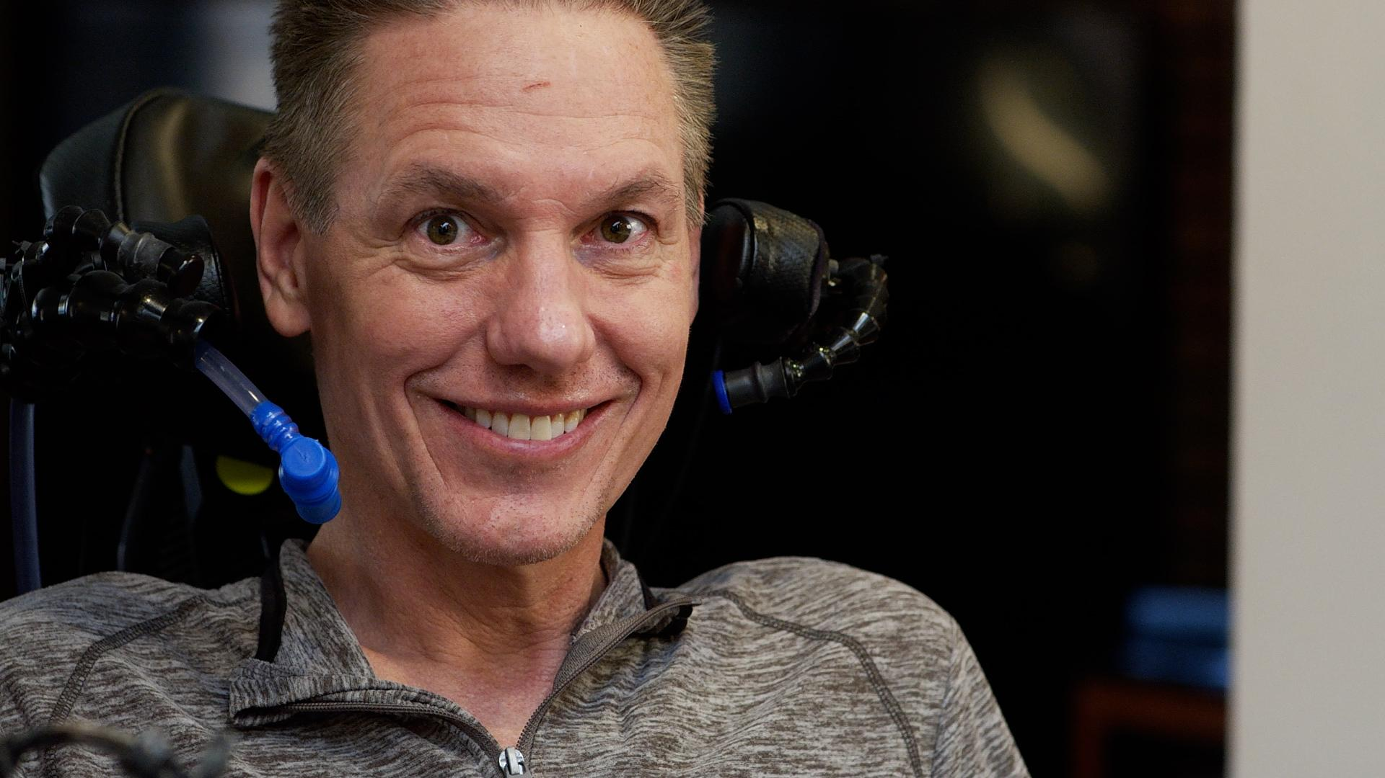

Please share Tom’s story on social media
- Copy and paste content to your social media channels.
- Link to the relevant video, and tag @HealthFirstColorado on Facebook and Instagram.
- To view the video subtitles in Spanish, click the Settings icon, select Subtitles/CC, and then choose the language.

Social media
Facebook:

“I have angels in my life”

When Tom was diagnosed with ALS, he felt alone and unsure of what came next.

But with support from Health First Colorado, Tom has access to compassionate caregivers and health benefits that let him live with joy and purpose.

Watch Tom’s story and learn how Colorado’s Medicaid program can help you:

[YouTube link] (long version)

#HealthFirstColorado #Medicaid

X (formerly Twitter):

“There are so many people out there that are not getting the benefits I’m getting.”

Despite having ALS, Tom can live with joy and purpose thanks to the support and care coordination he receives—benefits of being a Health First Colorado member.

Watch the clip: [YouTube link] (short version)

#HealthFirstColorado #Medicaid

Instagram:

“I didn’t expect Health First [Colorado] to be so amazing. It’s like Christmas Day every morning!”

After being diagnosed with ALS, Tom, a former athlete, felt alone and unsure of what came next.

But as a member of Health First Colorado, Colorado’s Medicaid program, Tom has access to the support of compassionate caregivers.

Now Tom lives with genuine joy and helps others with ALS.

Watch how Health First Colorado makes a difference in Tom’s life.

[YouTube link] (long version)

#HealthFirstColorado #Medicaid

Newsletter
Copy and paste content to your newsletters. Use an image and link to the video on YouTube.

Title: Tom’s story: Living with ALS and finding support though Health First Colorado

When Tom was diagnosed with ALS, a disease that slowly weakens muscles, he felt alone and unsure of what came next.

But through a partnership with Colorado Community Health Alliance, Health First Colorado connected Tom to caregivers.

“You’re not alone in the journey,” his care coordinator told Tom.

Now, Tom can live with joy and purpose. He uses his programming skills to help others living with ALS.

“There are so many others out there that are not getting the benefits that I'm getting,” said Tom. “I want to do everything I can to help them.”

Health First Colorado members like Tom want Coloradans to know that they may qualify for quality health care coverage.

Watch Tom’s story and learn how Health First Colorado, Colorado’s Medicaid program, supports its members.

