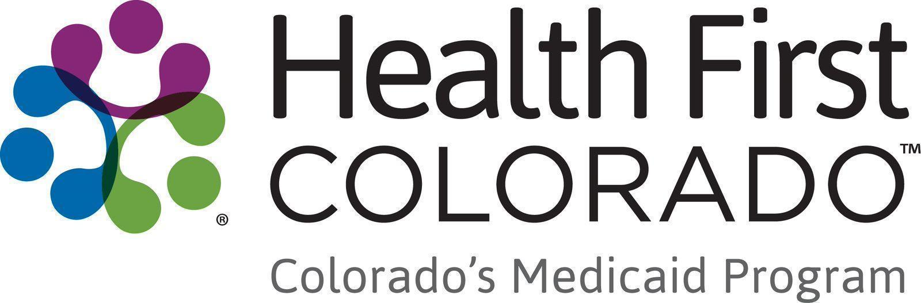

Member Videos Toolkit
Thank you for helping share the impact that Health First Colorado has on Coloradans across the state.

If you have any questions about the materials in this toolkit, please email Thessica Covato at thessica.covato@state.co.us

Charles’s Story

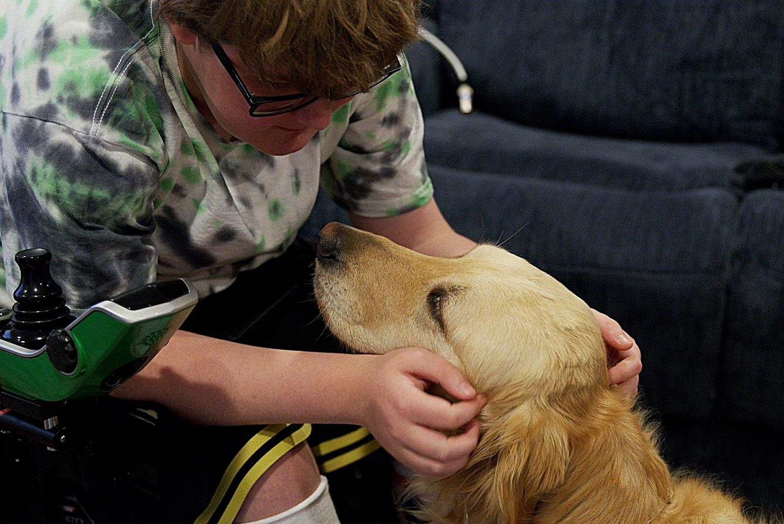

Please share Charles’s story on social media
- Copy and paste content to your social media channels.
- Link to the relevant video, and tag @HealthFirstColorado on Facebook and Instagram.
- To view the video subtitles in Spanish, click the Settings icon, select Subtitles/CC, and then choose the language.

Social media
Facebook:

“For me to be independent is a big deal,” says Charles, a 14-year-old Coloradan living with Duchenne muscular dystrophy.

Health First Colorado’s Children with Complex Health Needs Waiver provides Charles support with medical needs as well as an in-home support caregiver—a role his mom, Jessie, is able to take on.

Jessie says, “It’s helped us turn the corner—from ‘this is really hard’ to ‘we can do hard things.’”

Watch Charles’s story and learn how Colorado’s Medicaid program can help you:

[YouTube link] (long version)

#HealthFirstColorado #Medicaid

X (formerly Twitter):

“For me to be independent is a big deal.”

With support from Health First Colorado (Colorado’s Medicaid program) Charles, a 14-year-old Coloradan with Duchenne muscular dystrophy is thriving and showing his family what true strength looks like.

Watch the clip: [YouTube link] (short version)

#HealthFirstColorado #Medicaid

Instagram:

After Jessie’s son, Charles, was diagnosed with Duchenne muscular dystrophy, the monthly out-of-pocket costs started adding up, even with health insurance.

That’s when they turned to Health First Colorado (Colorado’s Medicaid program)

Through the Children with Complex Health Needs Waiver, they received help with medical costs and in-home caregiver support—allowing Jessie to take on that role herself.

“It’s helped us turn the corner,” Jessie says. “From ‘this is really hard’ to ‘we can do hard things.’”

Watch Charles’s story and learn how Colorado’s Medicaid program can help you:

[YouTube link] (long version)

#HealthFirstColorado #Medicaid

Newsletter
Copy and paste content to your newsletters. Use an image and link to the video on YouTube.

Title: Charles’s story:

When her son, Charles, was diagnosed with Duchenne’s muscular dystrophy, Jessie, a long-time health and human services professional, found herself “on the other side of the table,” facing medical bills that reached thousands each month.

That’s when the family turned to Health First Colorado. Through the Children with Complex Health Needs Waiver, they received help with medical costs and in-home caregiver support—allowing Jessie to take on that role herself.

“It’s helped us turn the corner,” she says. “From ‘this is really hard’ to ‘we can do hard things.’”

Her son’s strength inspires the whole family. “He teaches us every day,” Jessie adds. “Without Health First Colorado, none of this would be possible.”

Health First Colorado members like Jessie and Charles want Coloradans to know that they may qualify for quality health care coverage.

Watch Charles’s story and learn how Health First Colorado, Colorado’s Medicaid program, supports its members.

