[APRIL 2026]

[April 2]
The Health First Colorado website has a brand-new look! We’ve made it easier to navigate, added content and redesigned FAQs to help you find what you need faster. We will continue to update and improve the site over time, especially as we expand our Spanish-language content. Check it out and let us know what you think!

HealthFirstColorado.com/es/

#Colorado #HealthFirstColorado #Medicaid #CO

[Alt text] Screenshot of Health First Colorado website's new look.

[April 3]
Check out our new FAQ section! Get answers to common questions about how recent federal legislation may affect Health First Colorado (Colorado's Medicaid program) members.

Read the FAQ: HealthFirstColorado.com/es/preguntas-frecuentes-health-first-colorado/preguntas-frecuentes-de-los-requisitos-de-participacion-comunitaria-y-laborales/

#Colorado #HealthFirstColorado #Medicaid #CO

[Alt text]
Check out our new FAQs frequently asked questions section!
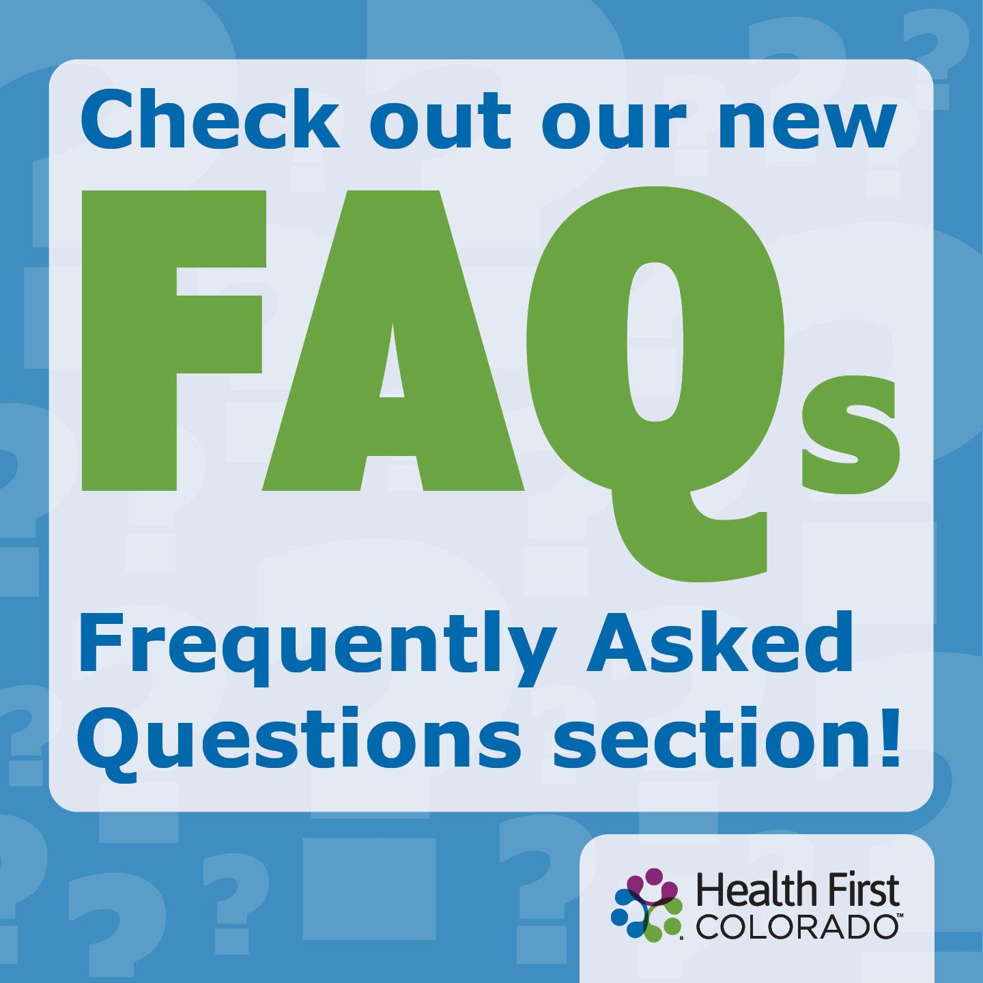

[April 6]
Question of the Week: [Content previously translated]

Find more FAQs on how the recent federal legislation may affect Health First Colorado (Colorado's Medicaid program) members at HealthFirstColorado.com/es/preguntas-frecuentes-health-first-colorado/preguntas-frecuentes-de-los-requisitos-de-participacion-comunitaria-y-laborales/

#Colorado #HealthFirstColorado #Medicaid #CO

[Alt text]

[April 7]

Big changes are coming to Health First Colorado (Colorado's Medicaid program) in 2026 and 2027.

Find out how recent federal legislation may affect how you qualify for health coverage:
HealthFirstColorado.com/es/changes-are-coming-to-health-first-colorado-colorados-medicaid-program/

#Colorado #HealthFirstColorado #Medicaid #CO

[Alt text]

[April 21]
📣Health First Colorado Members: Have you tried the new work requirements screener tool on the Health First Colorado (Colorado's Medicaid program) website? The tool can help you determine if the new work requirements (coming in January 2027) might apply to you.

Try it here:
HealthFirstColorado.com/es/screener/

#Colorado #HealthFirstColorado #Medicaid #CO

[Alt Text] Screenshot of work requirements screener tool

[April 30]

👉Reminder: A new federal law will make it harder for some people to keep their Health First Colorado (Colorado's Medicaid program) coverage or access care, beginning in October 2026. You will always receive an official notice if your coverage changes.

Make sure to keep your contact information up to date in Colorado PEAK, and always respond to official notices immediately or you could lose your health coverage.

https://peak.my.site.com/peak/s/peak-landing-page?language=es

#Colorado #HealthFirstColorado #Medicaid #CO

[Alt text]

