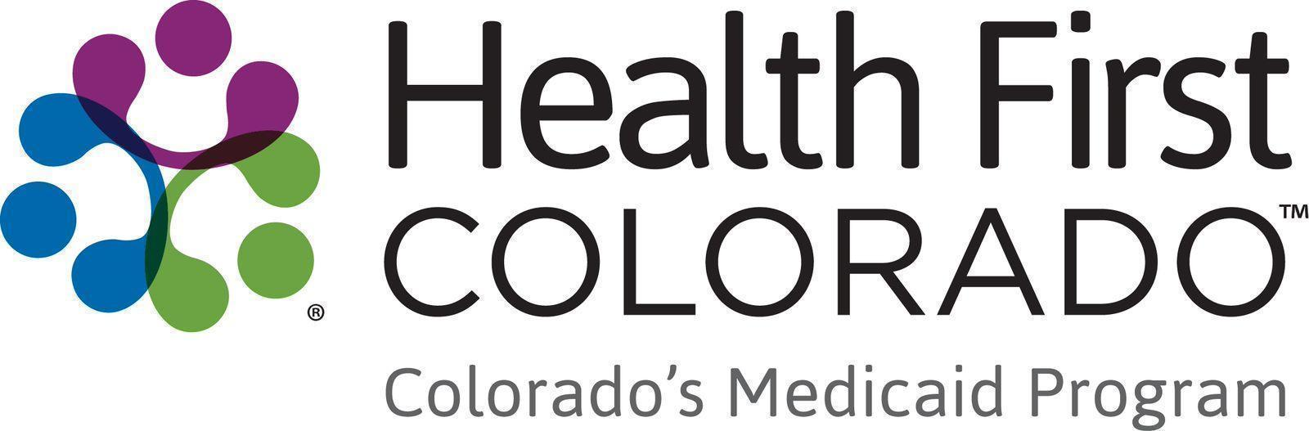

Member Videos Toolkit
Thank you for helping share the impact that Health First Colorado has on Coloradans across the state.

If you have any questions about the materials in this toolkit, please email Thessica Covato at thessica.covato@state.co.us

Judy’s Story

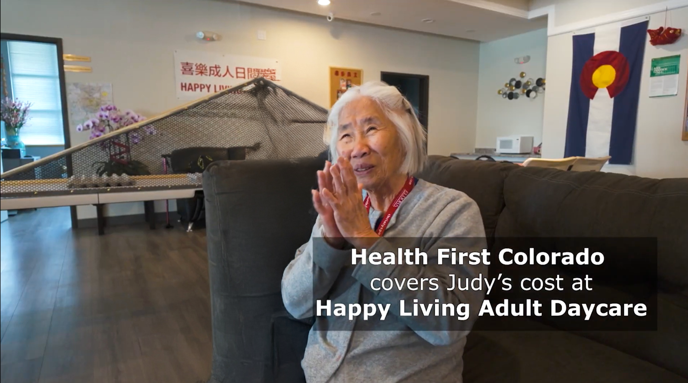

Please share Judy’s story on social media
- Copy and paste content to your social media channels.
- Link to the relevant video, and tag @HealthFirstColorado on Facebook and Instagram.
- To view the video subtitles in Spanish, click the Settings icon, select Subtitles/CC, and then choose the language.

Social media
Facebook:
Whether she’s playing Mah Jong with friends, laughing with her daughter, or reconnecting with her roots, Judy is thriving in a safe and supportive environment surrounded by her peers.
“For me, it gives peace of mind. It gives my whole family peace of mind,” her daughter Jennie says. “Without Health First, she would be sitting at home falling asleep on the couch. She would be a shell of a person.”
Colorado’s Medicaid program, Health First Colorado, helps make adult day services possible, including transportation.
Watch Judy’s story and see how Health First Colorado supports its members and their families.
[link]

#HealthFirstColorado #Medicaid

X (formerly Twitter):
Judy’s smile is brightest when she’s playing Mah Jong with her friends.
Adult day services through Happy Living Adult Daycare have helped Judy, who lives with dementia stay active, social, and joyful. Colorado’s Medicaid program, Health First Colorado, covers these services.
“Without Health First, she would be sitting at home falling asleep on the couch. She would be a shell of a person,” says her daughter Jennie.
Instead of spending her days isolated at home, Judy is surrounded by friends and connecting with her culture.
Watch Judy’s inspiring story: [Insert Link]
#HealthFirstColorado #Medicaid

Instagram:
Living with dementia can be isolating. But thanks to Happy Living Adult Daycare and Colorado’s Medicaid program, Health First Colorado, Judy has a place where she can laugh, connect, play Mah Jong, and spend time with her friends in a safe and caring environment.
“It just makes me feel full. It makes me full that she's got a little bit of herself,” Jennie says.
Judy’s story shows how access to adult day services can make a meaningful difference for members and caregivers alike.
Watch her story here: [Insert Link]

#HealthFirstColorado #Medicaid

Newsletter
Copy and paste content to your newsletters. Use an image and link to the video on YouTube.

Title: Judy’s story: Staying active, joyful and social while living with dementia
Living with dementia has changed many things for Judy and her daughter, Jennie. But thanks to Happy Living Adult Daycare and Health First Colorado, Colorado’s Medicaid program, Judy still has connection, joy, enrichment and community.
Whether she’s playing Mah Jong with friends, laughing with her daughter, or reconnecting with her roots, Judy is thriving in a safe and supportive environment surrounded by her friends.
“It just makes me feel full. It makes me full that she's got a little bit of herself,” Jennie says. “Without Health First, she would be sitting at home falling asleep on the couch. She would be a shell of a person.”
Health First Colorado helps make adult day services possible, including transportation, so families like Judy’s can access the care and support they need.
Watch Judy’s story and see how Health First Colorado supports its members.

