

[v_Head_of_Households_Name] [v_Case_Mailing_Address_Full_3_Lines]
Date of Notice: [v_Date_current_date] CBMS Case#: [v_Case_Number]

Supplemental Nutrition Assistance Program (SNAP) Request for More Information

We Need Additional Information From You

Dear [v_Head_of_Households_Name],

You reported a change of address on [v_SNAP_CRF_date]. Because you moved, we need more information about your shelter and utility expenses. We need this information to help us decide if there should be any changes to your SNAP benefits. You may qualify for more benefits if your shelter expenses have increased from the amount we currently have budgeted on your case. This letter lists what we need and what steps you should take to get it to us.

What do you need to do?
Please confirm or update the expenses listed on the following pages by [v_SNAP_Due_date]. How can you give us the information we need?
Choose the option that is easiest for you.

Online:
Upload this completed document at CO.gov/PEAK or by using the MyCOBenefits mobile app on your smartphone. If you do not have an account, you can create one.

In-person or by mail:
Drop off this completed document at your local office front desk or drop box. You may also mail this document to:
[v_SNAP_County_Name] County Human Services [v_SNAP_County_Address_Full_3_Lines]

*Send copies, not original documents. We cannot return any original documents to you.
- By fax: [v_SNAP_County_Fax]

If you need help completing this document, contact your county worker.

What will happen to your benefits?
If you do not give us the information we need by [v_SNAP_Due_date] there may be a change to your SNAP benefits. If this happens, you will get a separate letter telling you the amount changed and what you can do to appeal.

What if you need more help?

If you have questions, need to update your information, or need help understanding this notice, please contact us:

 | Phone: [v_Primary_Worker_Correspondence_Phone]  Toll-Free: [County Toll-Free Number or 1-800-816-4451]
 | PEAK: http://CO.gov/PEAK  - Sign up to go paperless, get email or text notifications  - See what benefits you have and when they need to be renewed  - Report changes  - Apply for other benefits
 | Mailing Address:  [v_Worker_Office_Mailing_Address_Line_1] [v_Worker_Office_Mailing_Address_Line_2] [v_Worker_Office_Mailing_Address_Line_3]
 | In-person Services:  [v_Worker_Office_Physical_Address_Line_1] [v_Worker_Office_Physical_Address_Line_2] [v_Worker_Office_Physical_Address_Line_3]
 | Fax:  [County Fax Number]

For notices in large print or another format, please call our helpline at [v_Primary_Worker_Correspondence_Phone] TDD (telecommunication device for the deaf).
Si lo solicita, podemos traducir esta información para usted. Por favor, llame [v_Primary_Worker_Correspondence_Phone].

Help in your Language

Cash Assistance: [v_Bable_contact_CA]
Supplemental Nutrition Assistance Program (SNAP): [v_Bable_contact_FA]
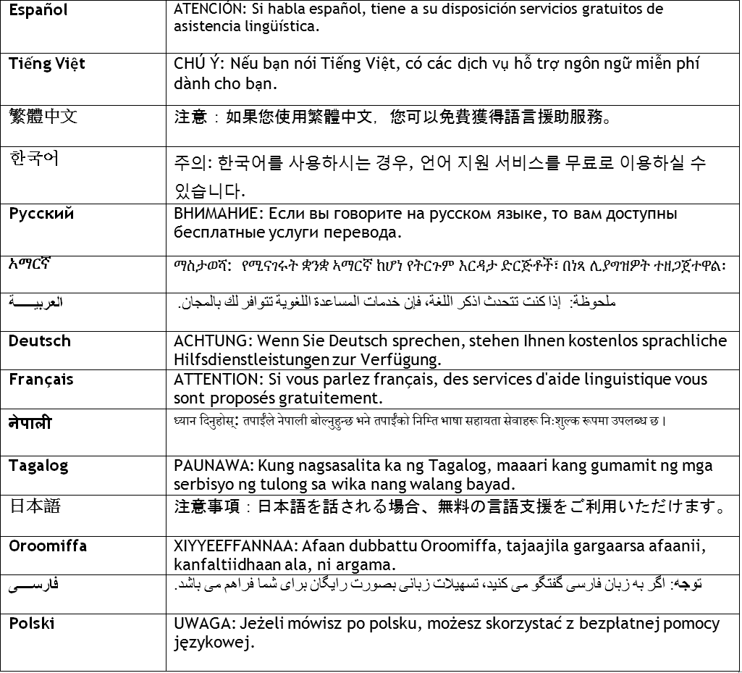



SNAP Request for More Information, Address Change

Sent to:
[v_Case_Name] [v_Case_Mailing_Address_Full_3_Lines]
Case #: [v_Case_Number]

To complete this form, please:
!
Return this form to:
[v_Primary_Worker_Correspondence_Name] [v_Worker_Office_Physical_Addr_Full_3_Lines] [v_Primary_Worker_Correspondence_Phone]
Return form by:
[v_SNAP_Due_Date]
- Use block letters and write using BLUE or BLACK ink
- Review all pre-filled information (grey fields) for accuracy
- Any rows filled with “XXXXX” do not require your review.
- If you need additional space than what is provided, please send this form
back with additional pages
- If you need assistance completing this form, contact the county office


1 By signing below:
- I understand that any changes reported can result in an increase, reduction, or termination of benefits.
- Turning this form in incomplete and/or after the due date can result in a delay of benefits being issued.
- I have read this form to continue my benefits and to the best of my knowledge and belief, my answers are true. This information
includes the shelter and utility expenses I am currently responsible for at my new address.
- I understand and agree to the information provided in the section titled “What I Should Know.”
- I have the right to apply again for SNAP benefits by submitting an application for assistance as long as it has my name, address, and signature. I can send this application in by mail, drop it off at the county office, or through an authorized representative. If everyone in my household receives SSI, I can apply again for benefits at the local Social Security office.

SIGN HERE DATE SIGNED (MM/DD/YYYY):

/ /

2
Please report if you have any changes in what you pay for rent/mortgage, home insurance, property taxes, HOA fees, and utilities, AND if you have any new things that you pay for:
2A
Update currently on-file information about expenses in your household:

Person Responsible for Expense | Type of Expense | Amount | How Often Billed | Change |  | How much was the last bill? (If you are no longer responsible for this, please write 0) | How Often is this person billed?
[v_indvName] | [v_expType] | [v_expAmou nt] | [v_frequenc y] | YES | NO | $
XXXXXXXXXXXX | XXXXXXXXXXXXX | XXXXXX | XXXXXXX | YES | NO | $
XXXXXXXXXXXX | XXXXXXXXXXXXX | XXXXXX | XXXXXXX | YES | NO | $
XXXXXXXXXXXX | XXXXXXXXXXXXX | XXXXXX | XXXXXXX | YES | NO | $
XXXXXXXXXXXX | XXXXXXXXXXXXX | XXXXXX | XXXXXXX | YES | NO | $
XXXXXXXXXXXX | XXXXXXXXXXXXX | XXXXXX | XXXXXXX | YES | NO | $
XXXXXXXXXXXX | XXXXXXXXXXXXX | XXXXXX | XXXXXXX | YES | NO | $
XXXXXXXXXXXX | XXXXXXXXXXXXX | XXXXXX | XXXXXXX | YES | NO | $

2B If your household has any new expenses, please report below. Even if you are behind on paying bills, let us know how much you are responsible to pay when answering questions about your expenses:
Expense Type: Rent/Mortgage Heating/Cooling
Electricity Only
Water Trash
Phone Other:
Weekly
Every 2 Weeks
Monthly
Other:
#1
Person Responsible for Expense:
When did this person become responsible

for this expense? (MM/DD/YYYY) / /
Amount: How often?
$

#2
Expense Type: Rent/Mortgage Heating/Cooling
Electricity Only
Water Trash
Phone Other:
Weekly
Every 2 Weeks
Monthly
Other:
$
Person Responsible for Expense:

When did this person become responsible

for this expense? (MM/DD/YYYY) / /
Amount:

How often?

#3
Expense Type: Rent/Mortgage Heating/Cooling
Electricity Only
Water Trash
Phone Other:
Weekly
Every 2 Weeks
Monthly
Other:
$
Person Responsible for Expense:

When did this person become responsible

for this expense? (MM/DD/YYYY) / /
Amount:

How often?

Have you received LEAP (energy assistance) at this address in the past 12 months?
Do you receive housing assistance at your new address (i.e. Section 8, housing vouchers, etc)?
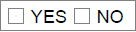
If yes:
Who is providing the assistance? How frequently is the assistance being provided? How much assistance is being provided?

