Community Partner Reference Guide

Community Partner Reference Guide for Translation

[page 1]


[image alt text] Four young adults stand outside talking and smiling together.

[title] Community Partner Reference:
Navigating Medicaid Coverage Changes for Some Immigrants

Health First Colorado (Colorado's Medicaid program)

Changes effective October 1, 2026 | FOR COMMUNITY PARTNER STAFF USE

[logo 1] [logo 2]
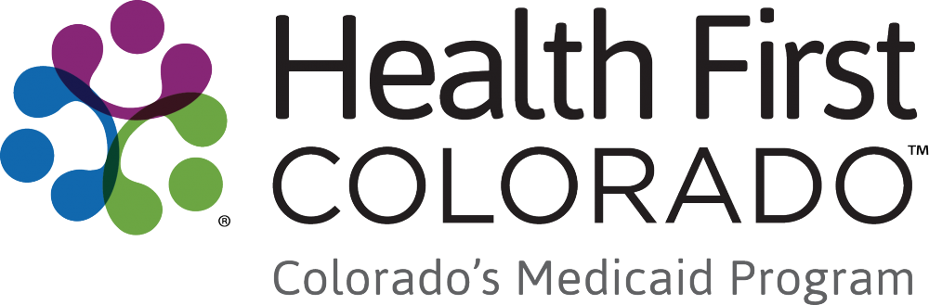

[page 2]
Remember: Members may be scared or confused. Lead with calm and compassion. You are often their first and most trusted point of contact.

Key challenge: Members may not receive mailed notices if their address on file is outdated. Proactive outreach by trusted staff is essential.

Eligibility reference — October 1, 2026

Current immigration status | May keep full coverage? | Options after October 1, 2026 | Language to use with member
U.S. citizens or U.S. nationals | YES | Health First Colorado | Good news — your coverage is not changing.
Lawful Permanent Resident status holders (LPR/green card) who meet the 5-year requirement | YES | Health First Colorado | Good news — your coverage is not changing.
Citizens of the Marshall Islands, Micronesia, or Palau living in the U.S. (COFA migrants) | YES | Health First Colorado | Good news — your coverage is not changing.
Certain current Cuban or Haitian entrants | YES | Health First Colorado | Good news — your coverage is not changing.
Children age 18 or younger* | YES | Health First Colorado | Your coverage is protected. Let’s confirm your status is on file.
Pregnant women, or pregnant within the last 12 months* | YES | Health First Colorado | Your coverage is protected. Let’s confirm your status is on file.
Current refugees or asylees | Only if pregnant or age 18 or younger† | Emergency Medicaid;  Connect for Health Colorado | This is a hard change. You still have some options — let’s look at them together.
People granted humanitarian parole | Only if pregnant or age 18 or younger† | Emergency Medicaid;  Connect for Health Colorado | This is a hard change. You still have some options — let’s look at them together.
People granted withholding of removal | Only if pregnant or age 18 or younger† | Emergency Medicaid;  Connect for Health Colorado | This is a hard change. You still have some options — let’s look at them together.
Survivors of domestic violence with a pending or approved application under the Violence Against Women Act | Only if pregnant or age 18 or younger† | Emergency Medicaid;  Connect for Health Colorado | This is a hard change. You still have some options — let’s look at them together.
Survivors of trafficking with a pending or approved application for a victim of trafficking visa | Only if pregnant or age 18 or younger† | Emergency Medicaid;  Connect for Health Colorado | This is a hard change. You still have some options — let’s look at them together.
Refugees with a “conditional entrant” status granted before 1980 | Only if pregnant or age 18 or younger† | Emergency Medicaid;  Connect for Health Colorado | This is a hard change. You still have some options — let’s look at them together.
Members of a U.S. federally recognized Indian tribe or American Indians born in Canada who do not yet have US citizenship | Only if pregnant or age 18 or younger† | Emergency Medicaid;  Connect for Health Colorado | This is a hard change. You still have some options — let’s look at them together.
Not lawfully present or undocumented | NO‡ | OmniSalud;  Cover All Coloradans | There are still programs that can help. Let’s find  the right one for you.
* This is not a complete list of lawfully present immigration statuses that may qualify children or pregnant women for coverage.
† May qualify for Cover All Coloradans coverage regardless of immigration status.
‡ May qualify for Emergency Medicaid Services and Reproductive Health Care Services; may qualify for Cover All Coloradans if pregnant or age 18 or younger.

Outreach guidance for navigators



[image alt text] Two young men looking at a phone together in an urban setting.

- Verify contact information at every opportunity
Ask members to update their information and communication preferences at co.gov/PEAK or with their community partner. An outdated address means missed notices.
- Members may have concerns about how their information will be used
Direct members to HealthFirstColorado.com/datasharing to learn how their information is used and protected.
- Lead with reassurance as many are not affected
Start by calming fears, then work through the details. Panic may shut down the conversation.
- Create urgency around using benefits now
Encourage appointments, dental, behavioral health and prescription refills before October 1.
- You are the trusted bridge
Members may fear government contact. Your relationship is the reason they’ll engage. Use it.
- Direct people to HealthFirstColorado.com/Changes
This is the official, up-to-date source for information and guidance. Point here rather than specific program details that may shift.
- Co-brand the member flyer
Add your logo and contact info to the companion flyer. Use it at appointments, waiting rooms and events. Access this and other H.R. 1 communications resources at hr1toolkit.healthfirstcolorado.com/

[left footer]
Official resources:
Latest updates: HealthFirstColorado.com/Changes
County services: cdhs.colorado.gov/contact-your-county
Colorado PEAK: co.gov/PEAK
Privacy: HealthFirstColorado.com/datasharing
Free language assistance available. Ayuda disponible en su idioma.

[middle footer]
YOUR AGENCY:
[ Agency logo ]
Organization: _______________________
Phone: _____________________________
Website: ____________________________

[right footer]
[QR code]
hfcgo.com/hr1flyer

