Immigrant Provisions Flyer

Immigrant Provisions Flyer for Translation

[page 1]



[image alt text] Father and child sitting together and talking on a couch at home.

[logo 1]
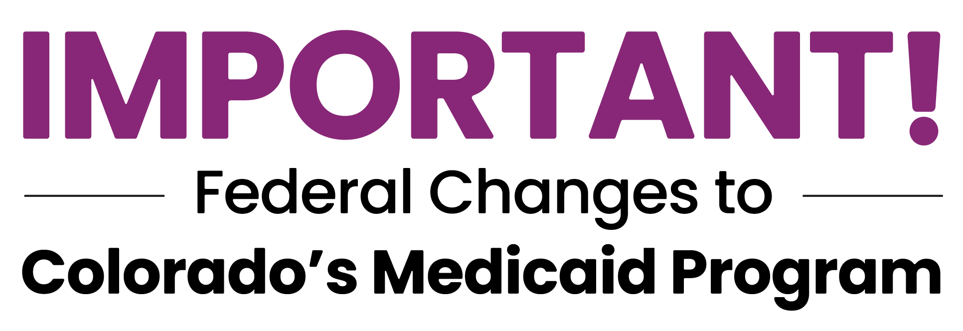

[title] Changes to Colorado Medicaid eligibility for some immigrants.

[dek] Starting October 1, 2026, some immigrants who currently qualify for Colorado’s Medicaid program, Health First Colorado, will lose health coverage because of federal changes to Medicaid.

[callout 1] Not everyone will lose coverage. Some people may still qualify for full coverage, limited services or other health care options.

Learn more at: HealthFirstColorado/Changes

Current immigration status | May qualify for full coverage after October 1, 2026
U.S. citizens or U.S. nationals | YES
Lawful Permanent Resident status holders (LPR/green card) who meet the 5-year requirement | YES
Citizens of the Marshall Islands, Micronesia, or Palau living in U.S. (COFA migrants) | YES
Certain current Cuban or Haitian entrants | YES
Children age 18 or younger* | YES
Pregnant women, or pregnant within the last 12 months* | YES
Current refugees or asylees | Only if pregnant or age 18 or younger†
People granted humanitarian parole | Only if pregnant or age 18 or younger†
People granted withholding of removal | Only if pregnant or age 18 or younger†
Survivors of domestic violence with a pending or approved application under the Violence Against Women Act (VAWA) | Only if pregnant or age 18 or younger†
Survivors of trafficking with a pending or approved application for a victim of trafficking visa (T-visa) | Only if pregnant or age 18 or younger†
Refugees with a “conditional entrant” status granted before 1980 | Only if pregnant or age 18 or younger†
Members of a U.S. federally recognized Indian tribe or American Indians born in Canada who do not yet have U.S. citizenship | Only if pregnant or age 18 or younger†
Not lawfully present or undocumented | NO‡
* This is not a complete list of lawfully present immigration statuses that may qualify children or pregnant women for coverage.
† May qualify for Cover All Coloradans coverage regardless of immigration status.
‡ May qualify for Emergency Medicaid Services and Reproductive Health Care Services; may qualify for Cover All Coloradans if pregnant or age 18 or younger.

[logo 2]
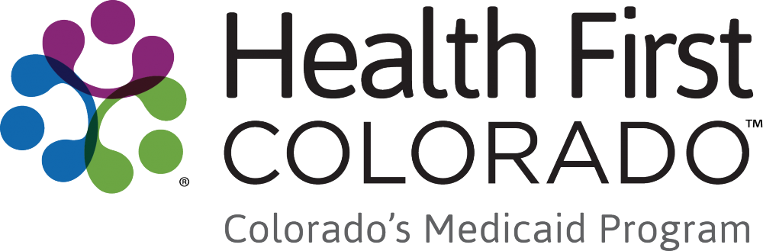

[page 2]


[image alt text] Parents walking with two children on a cobblestone street in a historic neighborhood, smiling and looking at one another.

What to do now, before October 1, 2026
- Update your information. Make sure your information is up to date. Call or visit your county human services office, or update online at Colorado PEAK: co.gov/PEAK
- Use your coverage now to get care. Schedule medical, dental and behavioral health appointments. Refill prescriptions to the limit allowed. Don't wait.
- Watch for official letters. Health First Colorado will mail a notice before anything changes to your coverage. Open and respond to any letters you receive.
- Reach out to someone you trust. Contact the person in your community or at your health care clinic who has helped you with Medicaid before. You don’t have to figure this out alone. Local organizations are ready to help.
[callout] Even without full coverage, you may still have options:
- Emergency Medicaid Services
- Reproductive Health Care Services
- Hospital Discounted Care
- Community Health Centers (sliding-scale fees)
- Connect for Health Colorado (private insurance)
- OmniSalud (undocumented Coloradans)
- Cover All Coloradans (children, pregnant, any immigration status)

[left footer]
Official resources:
Latest updates: HealthFirstColorado.com/Changes
County services: cdhs.colorado.gov/contact-your-county
Colorado PEAK: co.gov/PEAK
Privacy: HealthFirstColorado.com/datasharing
Free language assistance available. Ayuda disponible en su idioma.

[middle footer]
YOUR AGENCY:
[ Agency logo ]
Organization: _______________________
Phone: _____________________________
Website: ____________________________

[right footer]
[QR code]
hfcgo.com/hr1flyer

