Universal Post

Universal Post for Translation

[logo 1]
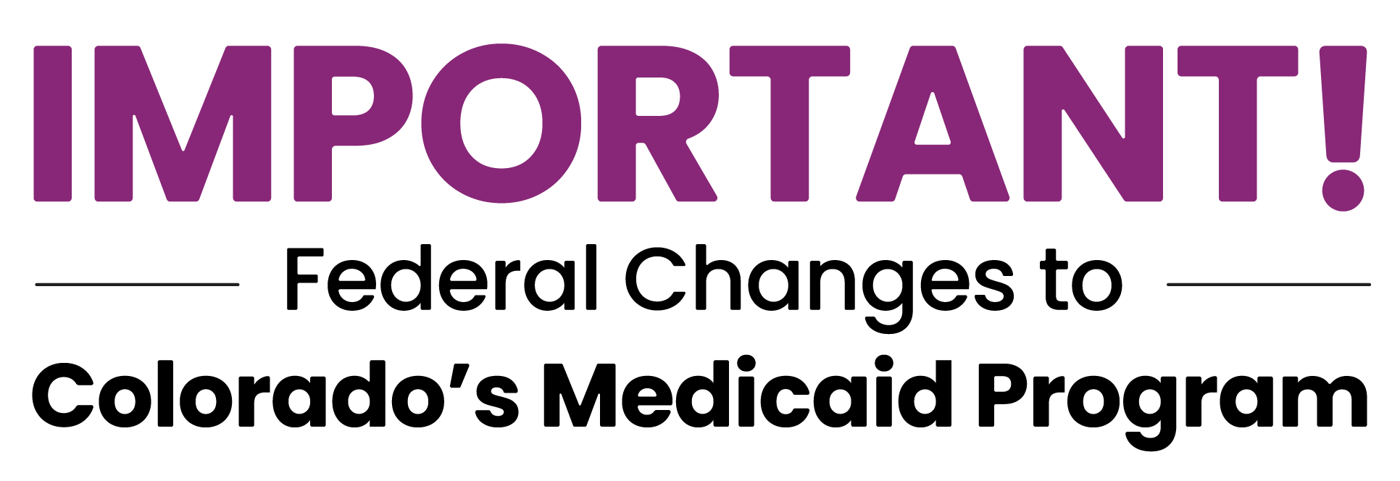

Starting October 1, 2026, some immigrants will lose Colorado’s Medicaid, Health First Colorado, coverage.

Local organizations are ready to help review your options.

- Many people are not affected
- Update your contact information
- Watch for and respond to official letters


[image alt text] A family of three poses together on a sunny trail with red rock hills in the background. A man wearing a grey T-shirt and shorts looks toward a woman who is holding a young girl and giving her a kiss on the cheek.

Footer copy:
For official guidance visit:
HealthFirstColorado.com/Changes

