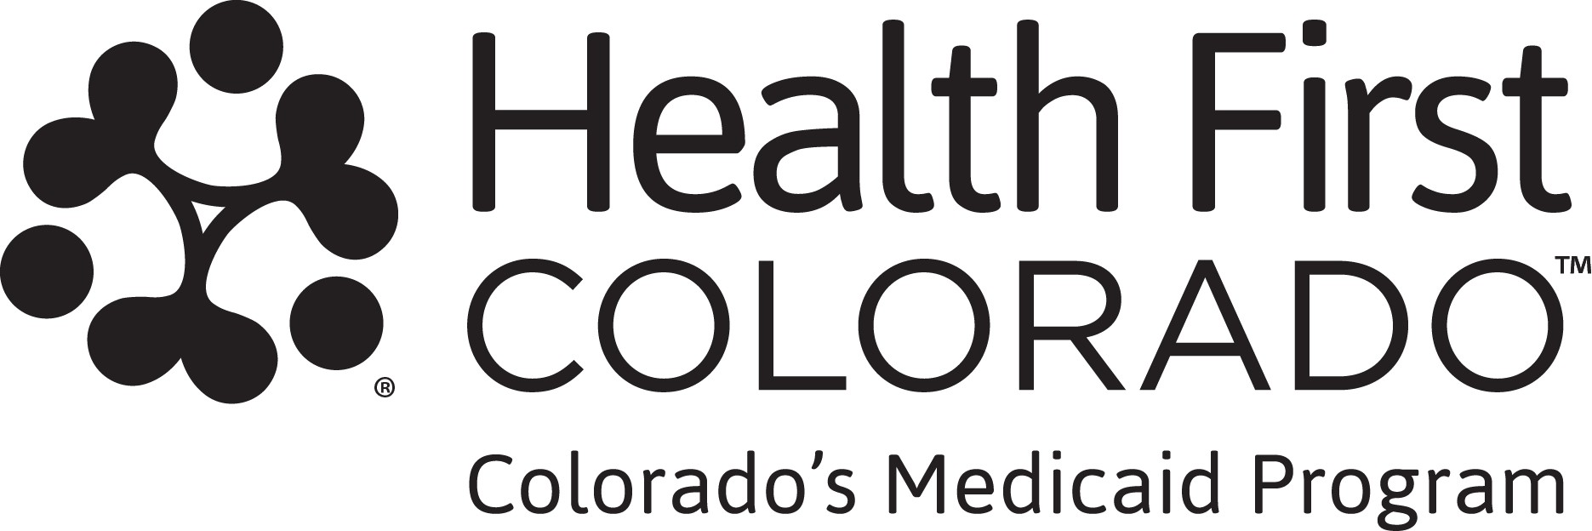

Work Program Verification Form
This form provides Health First Colorado (Colorado’s Medicaid program) with more information about your work program so we can know if you comply with work requirements, also known as community engagement.

What counts as a work program?

A work program is a structured employment or training program. It is managed, or recognized by, federal, state, or local government. Work programs help people get job skills or work experience, not just search for jobs.

- First-time applicants: Work program hours must be in the calendar month before you submitted your application for health coverage. If you requested retroactive coverage in your application, provide information for the 2 calendar months before you submitted your application.
- Renewing applicants: Work program hours must be in at least one calendar month since your previous renewal deadline. If you requested retroactive coverage in your renewal, provide information for the 2 calendar months before you submitted your renewal.

If you completed work program hours with more than one work program, make a copy of this form and complete a separate form for each.

Instructions for returning the form are on the first page of this letter. If your work program has its own form for tracking hours, you can submit that instead of this form.

Work Program Verification Form

Section 1. To be completed by the work program participant.

Work program participant’s name: [v_Indv_Name] Date of birth: [v Indv Date of Birth]
Work program name:

Enter dates and hours of participation

Work program start date: (MM/YYYY):

Work program end date: (MM/YYYY):

Total hours completed:
Section 2. This section should be completed by the person who supervises your work program.

By signing below, I certify that this work program is managed, or recognized by, federal, state, or local government, and all of the information provided above is true and accurate to the best of my knowledge.

Supervisor signature: Print supervisor name: Supervisor title: Date:
Phone number:

Email:

Which document to submit | Submission deadline for program
The completed and signed Work Program Verification Form included with this letter.  [insert system variable to populate specific month information is needed for particular applicant or renewing member]  If your qualified work program has its own official form, you can submit that instead of this form. The form must include:  -Work program name  -Work program participant name  -Participation dates and hours  -Supervisor name, phone number and email | [insert variable]

