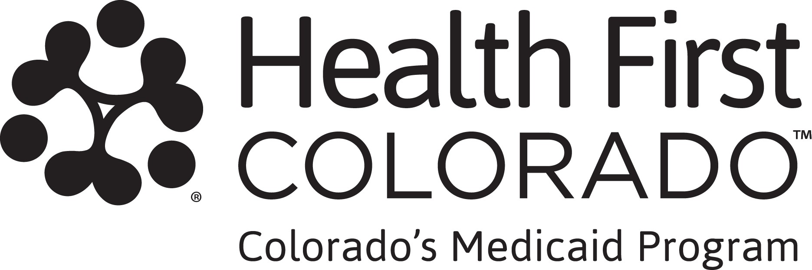

Volunteer Verification Form

This form provides Health First Colorado (Colorado’s Medicaid program) with more information about your volunteer hours so we can know if you comply with work requirements, also known as community engagement.

What counts as volunteer hours?

Volunteer hours you include on this form must be organized activities that benefit the community, usually through a public or nonprofit organization. These activities must serve a clear purpose, such as supporting health services, education, the environment, public safety, or child care. An eligibility site worker will review the activity you report on this form and decide if it counts toward work requirements.

- First-time applicants: Dates of service must be in the calendar month before you submitted your application for health coverage. If you requested retroactive coverage in your application, provide information for the 2 calendar months before you submitted your application.

- Renewing applicants: Dates of service must be in at least one calendar month since your previous renewal deadline. If you requested retroactive coverage in your renewal, provide information for the 2 calendar months before you submitted your renewal.

If you volunteered with more than one organization, make a copy of this form and complete a separate form for each volunteer role.
Instructions for returning the form are on the first page of this letter. If your volunteer organization has its own form for tracking hours, you can submit that instead of this form.

Volunteer Verification Form
Section 1. To be completed by the volunteer.

Volunteer’s name: [v_Indv_Name] Volunteer’s date of birth: [v Indv Date of Birth]
Volunteer’s position:

Volunteer organization name:

Address of organization:

Enter dates and hours of volunteer service

Start date of service (MM/YYYY):

End date of service: (MM/YYYY):

Total hours completed:
Section 2. This section should be completed by the person who oversees your volunteer activities.

By signing below, I certify that all of the information provided above is true and accurate to the best of my knowledge.

Supervisor signature: Print supervisor name: Supervisor title: Date:
Phone number:

Email:

Which document to submit | Submission deadline for program
The completed and signed Volunteer Verification Form included with this letter.  [insert system variable to populate specific month information is needed for particular applicant or renewing member]  If your volunteer organization has its own official form, you can submit that instead of this form. The form must include:  -Organization name and contact information  -Dates volunteered  -Hours volunteered  -Volunteer name | [Insert variable]

